[TC-MR12-37] Official Quote Automation – Finalize/Update Official Quote

Result 1: BUG

Testing sequence 1
1. New range defined for EEAS 2016.
2. Select "New Official Quote" from the form "Select Official Quote Mode"
3. Click "OK" to display "Request Official Quote". The form displays with EEAS 00001 value (default)
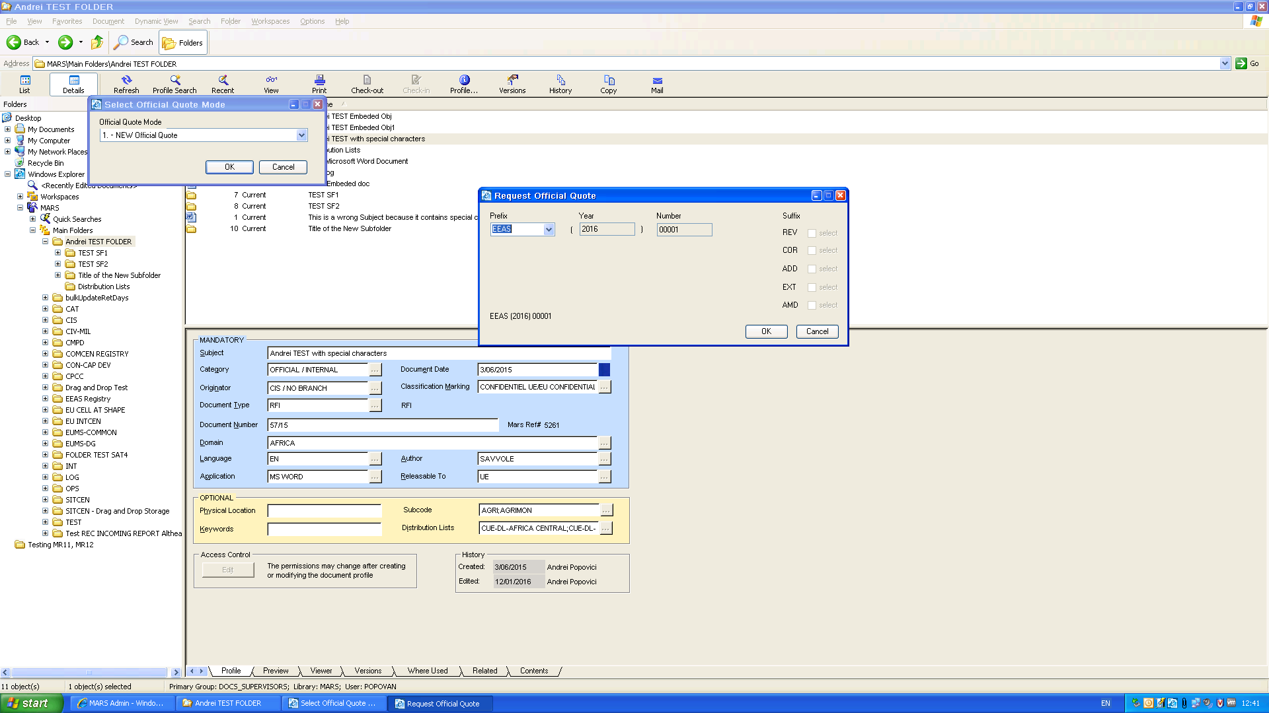
4. Click "Cancel";
5. Click "Cancel " in "Select Official Quote Mode". The EEAS index remain 00001.
6. Repeat from step 2-3. The form displays with EEAS 00002 value.
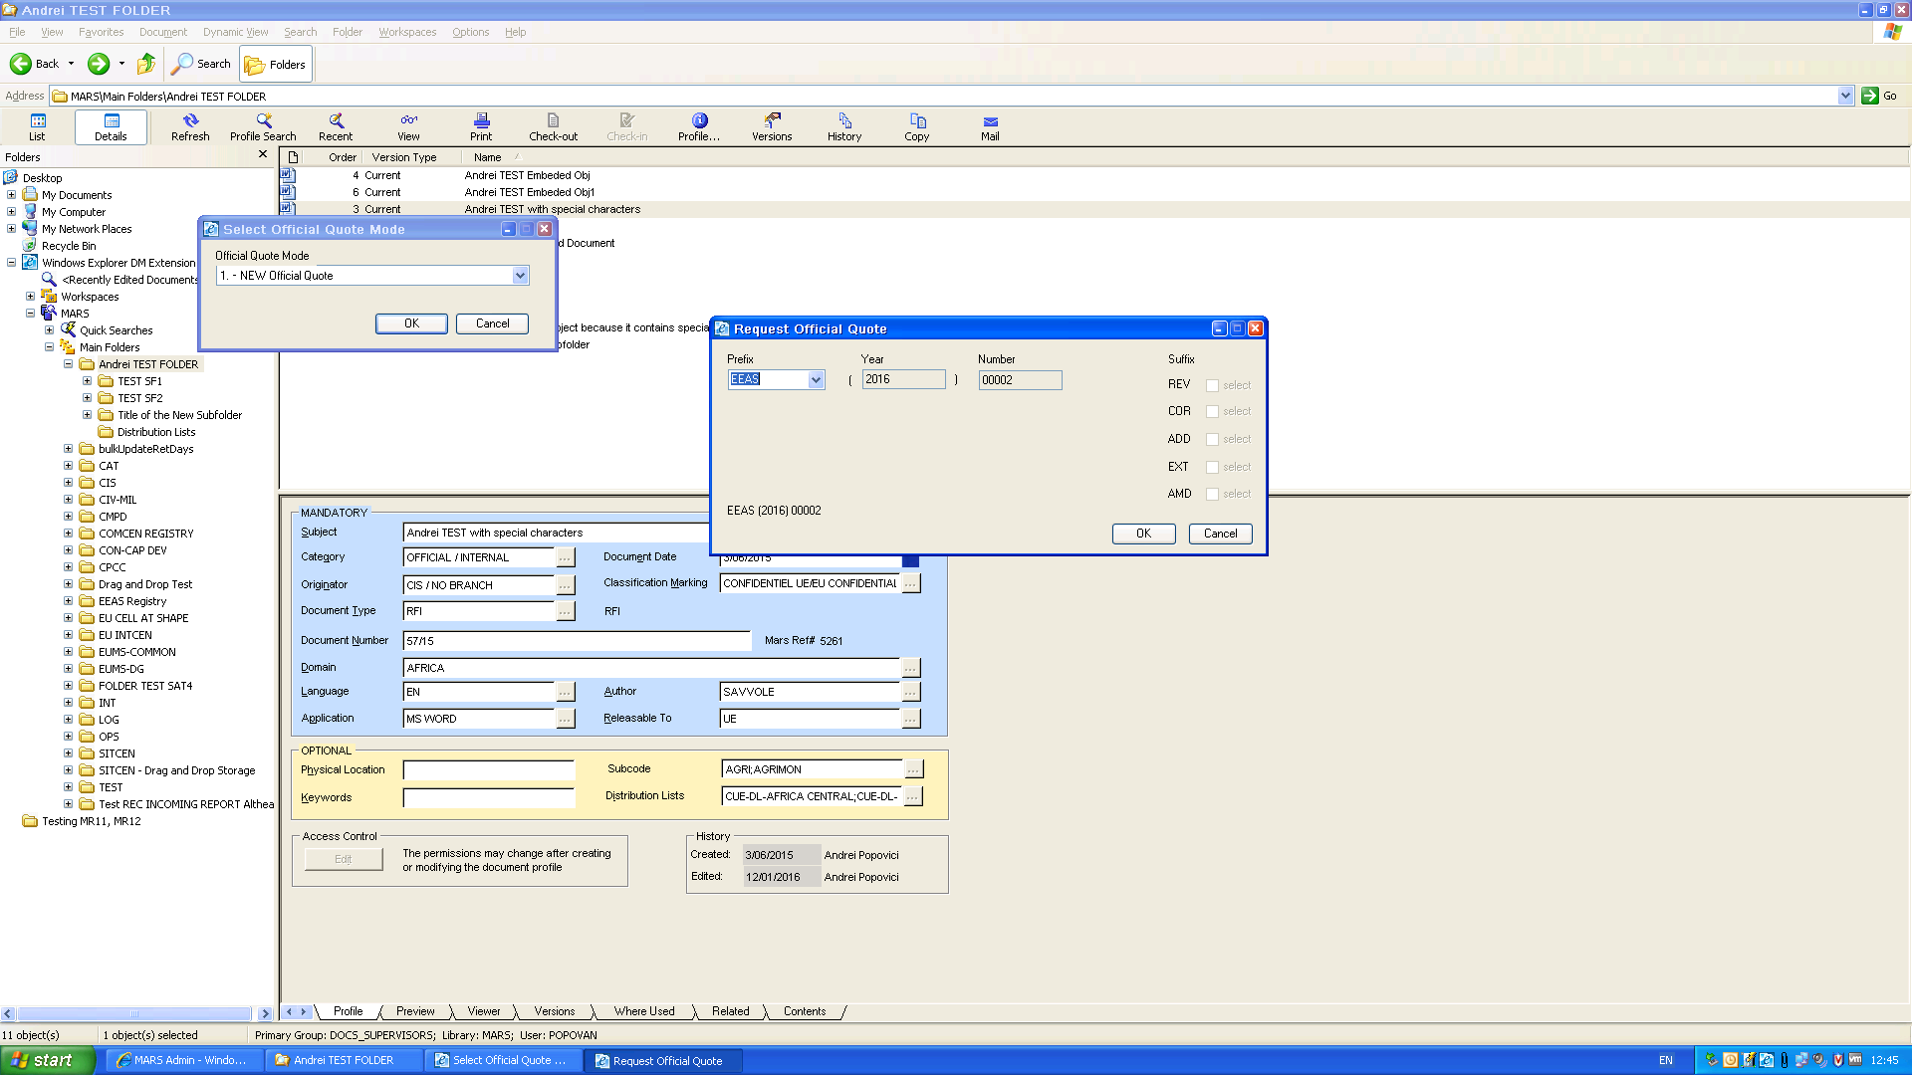
The accidental reset to EEAS 00001 described above and the rest of the steps are not recorded in the log :
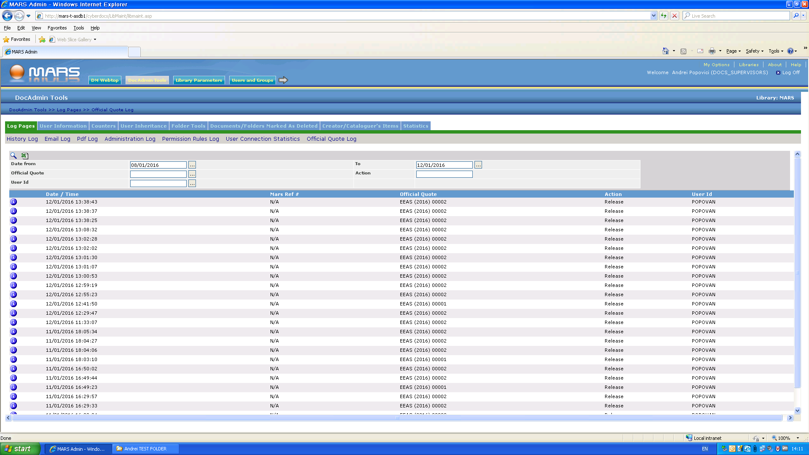
Actions intended to reproduce BUG1:
1. Select "New Official Quote" from the form "Select Official Quote Mode".
2. Click "OK" to display "Request Official Quote". The form displays with EEAS 00002 value (see BUG1), showing that a previous Official Quote has been booked already (which is false)
3. Click "Cancel". The form closes without saving again the current displayed value (EEAS 00002) which remains available for further bookings; The form "Select Official Quote Mode" is again available.
4. Click "OK" again; The form displays EEAS 00002 again.
5. We click "Cancel" again. The form "Select Official Quote Mode" is again available.
6. Click "Cancel" in "Select Official Quote Mode". Up to now we've tried to reproduce BUG1 ( pictures are taken from a second sequence of actions that somehow reset EEAS 00002 back to EEAS 00001)

1.2Testing sequence 2
1. Repeat Steps 1, 2 from"Testing sequence 1" to see the first value of EEAS official quote available.
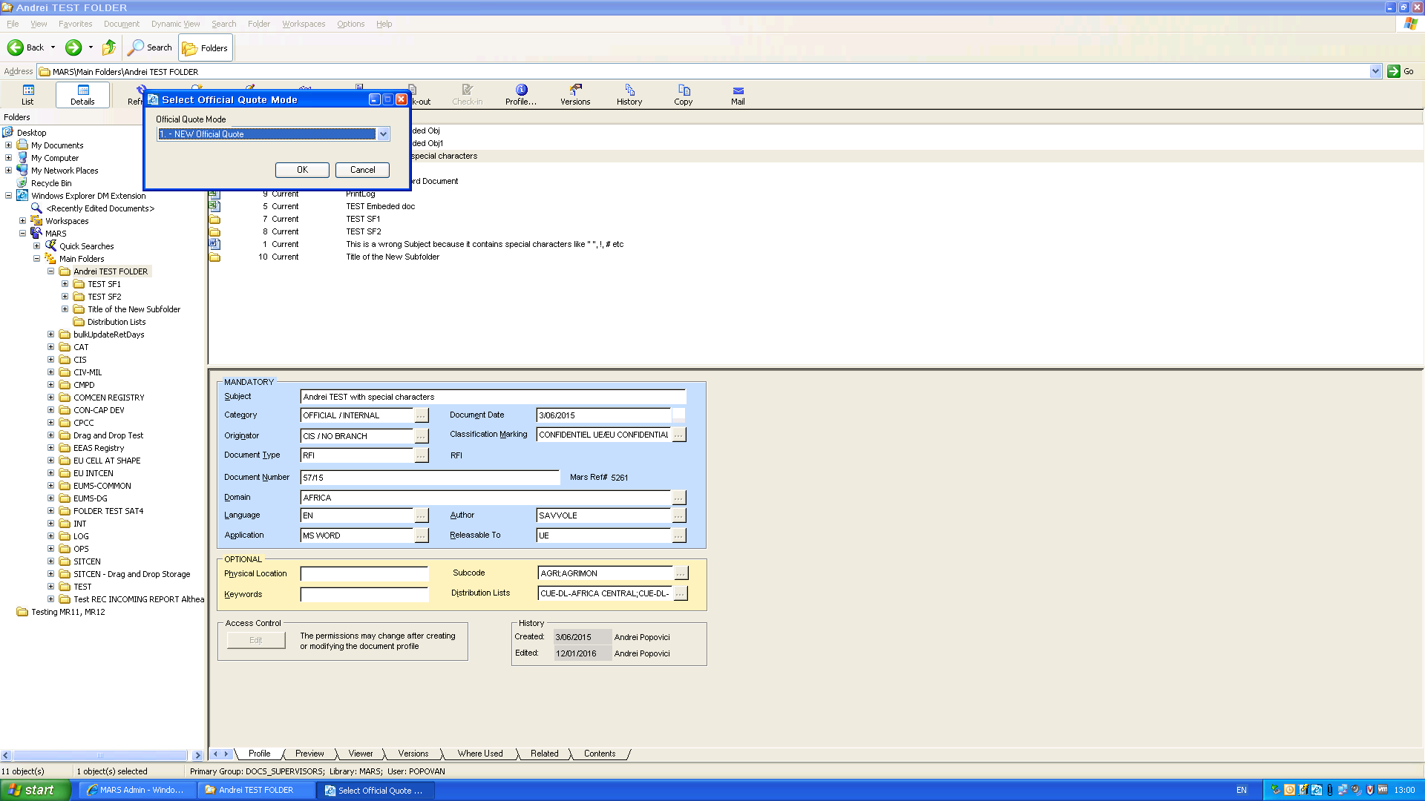
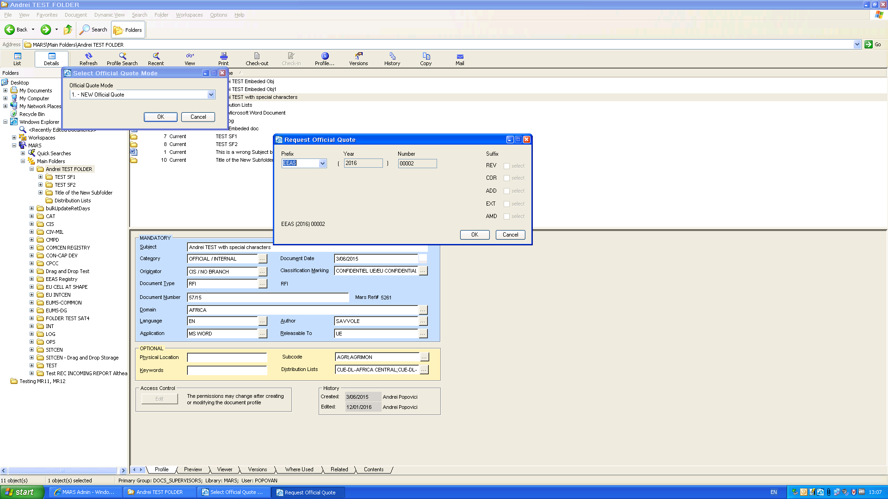
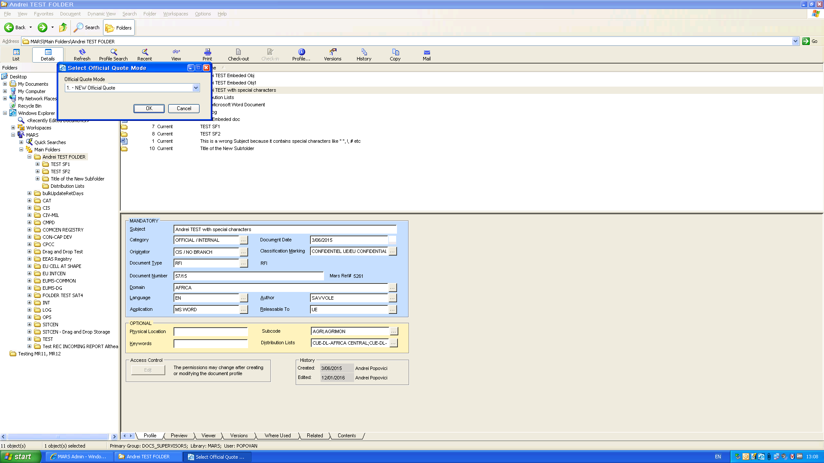
2. Click "Cancel" in "Select Official Quote Mode".

3. Select "Finalize" from the right click menu for one document.
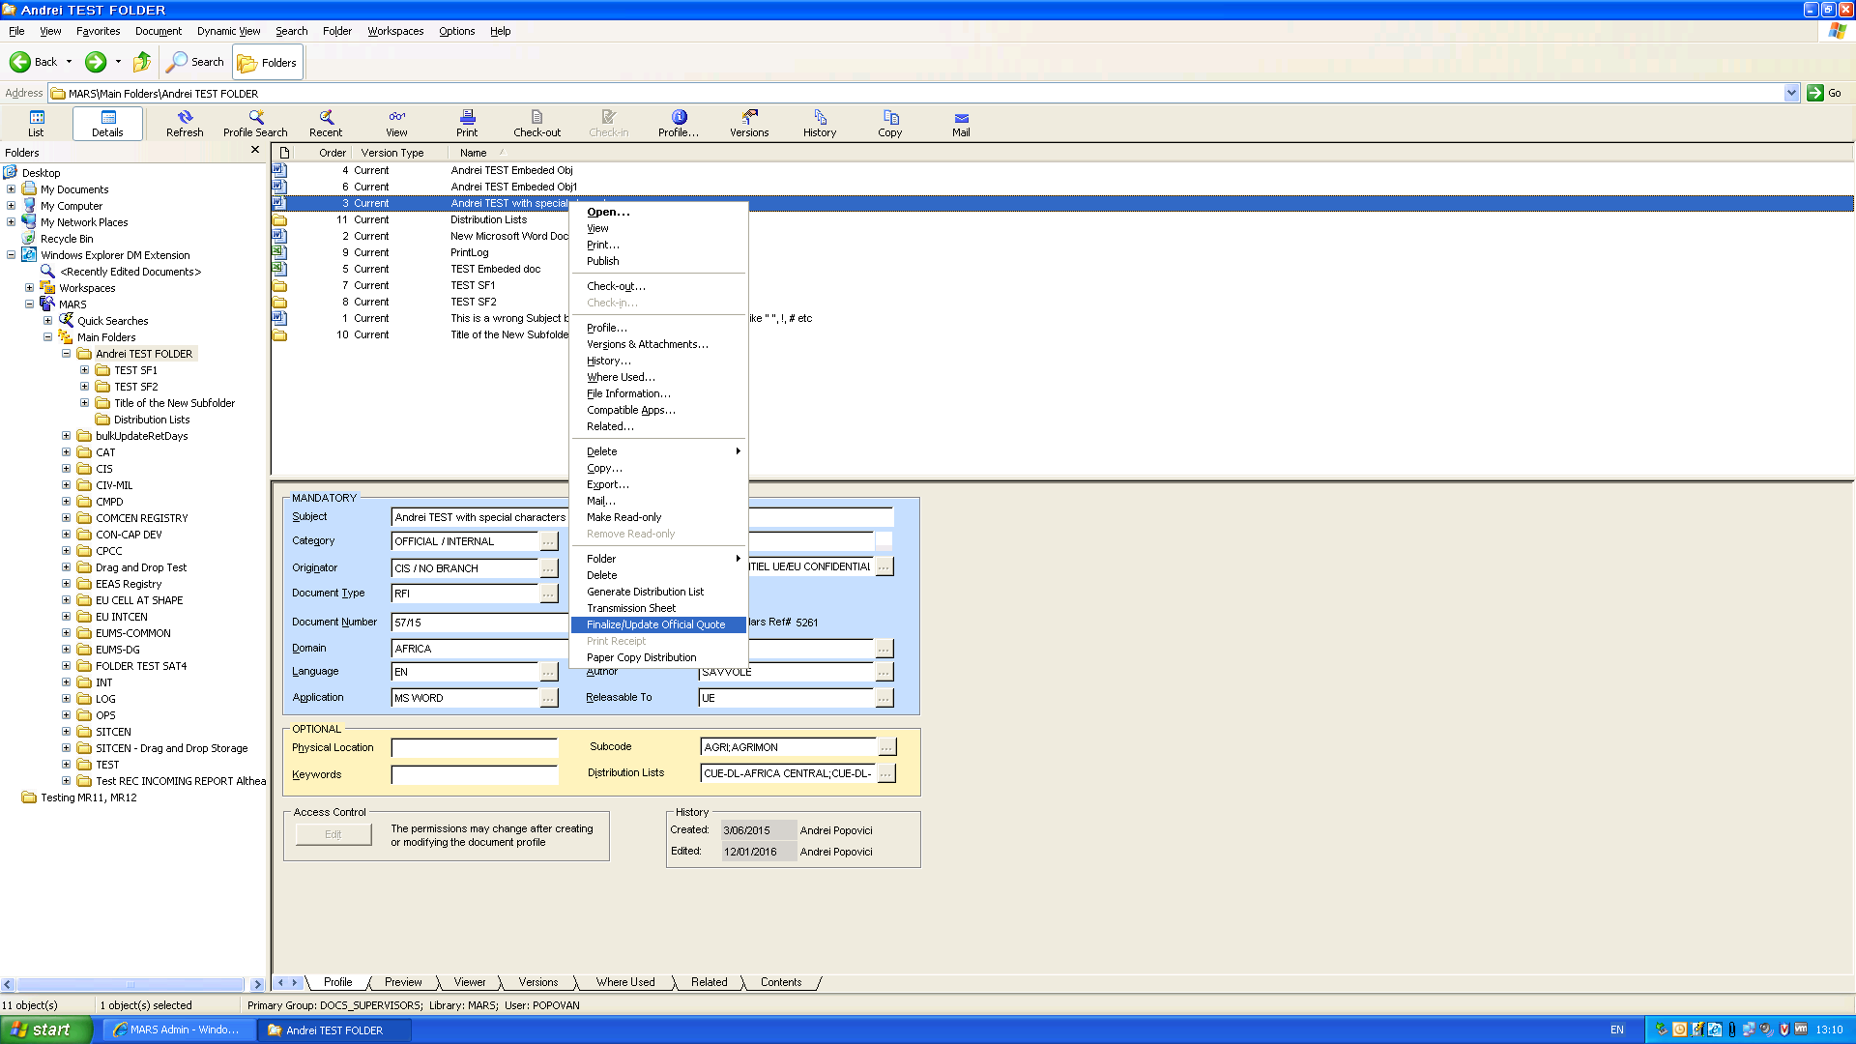
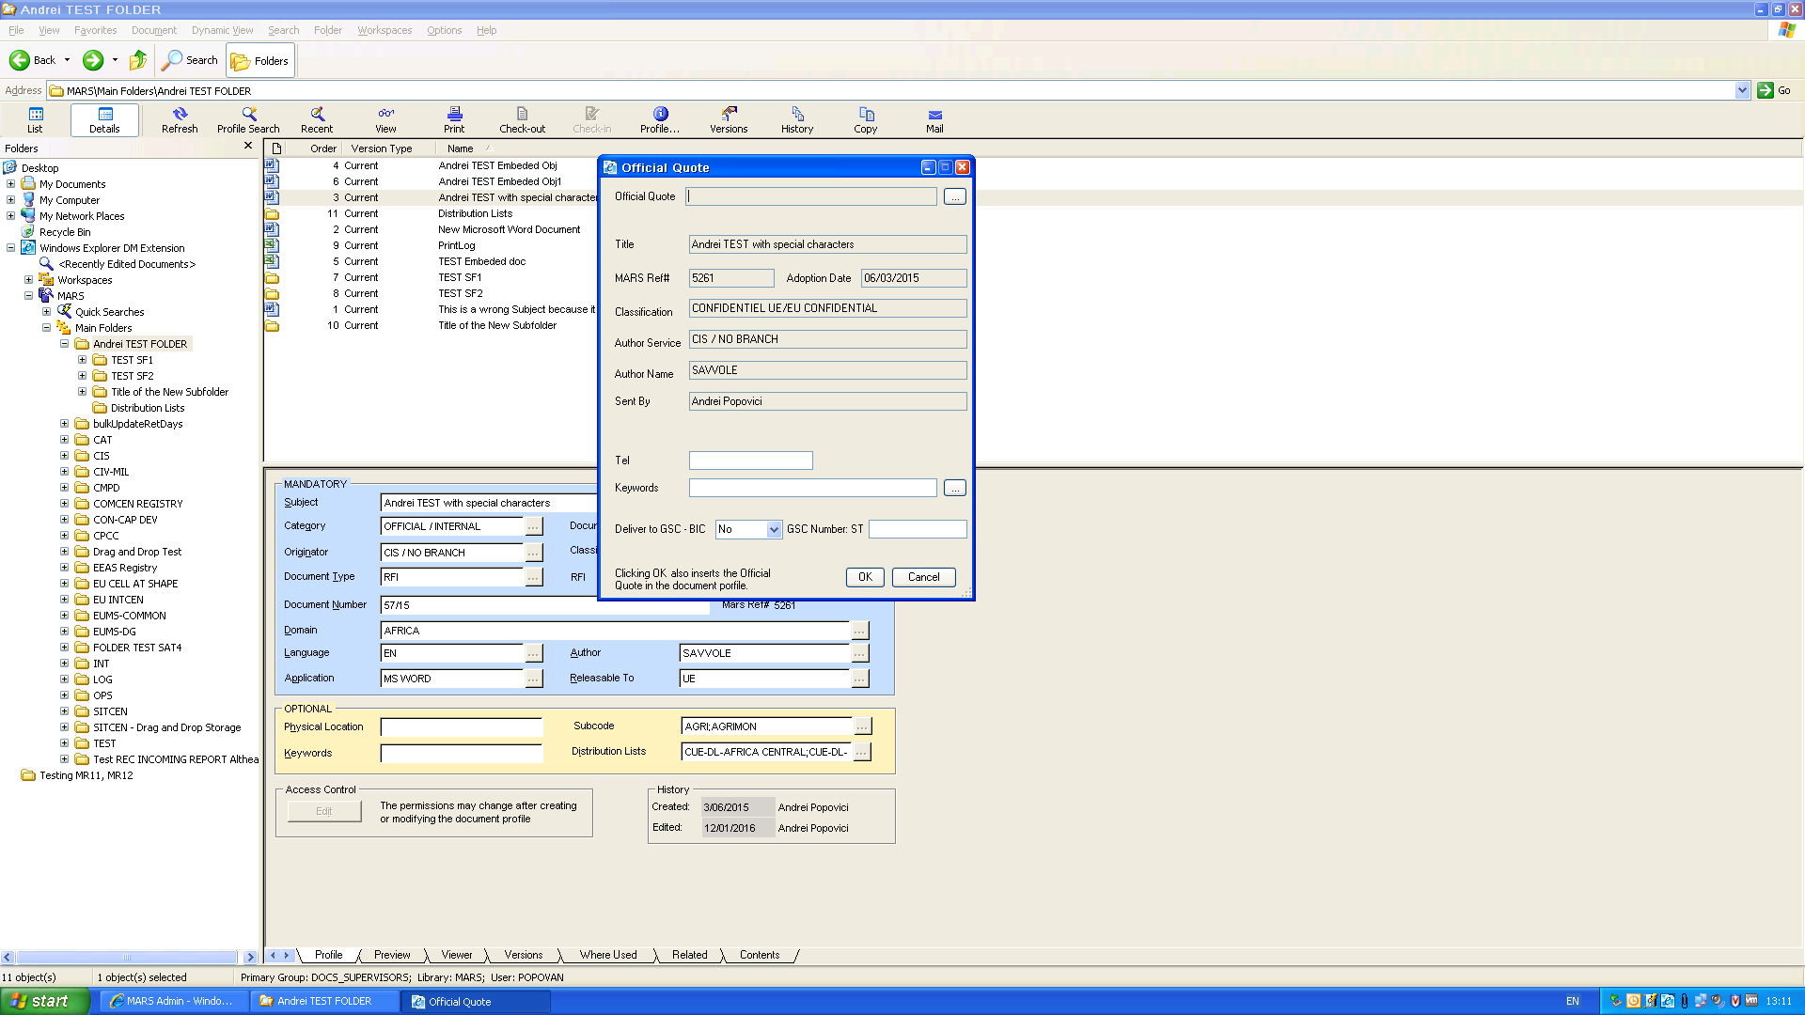

4. Click on the button for closed list of booked Official Quotes:
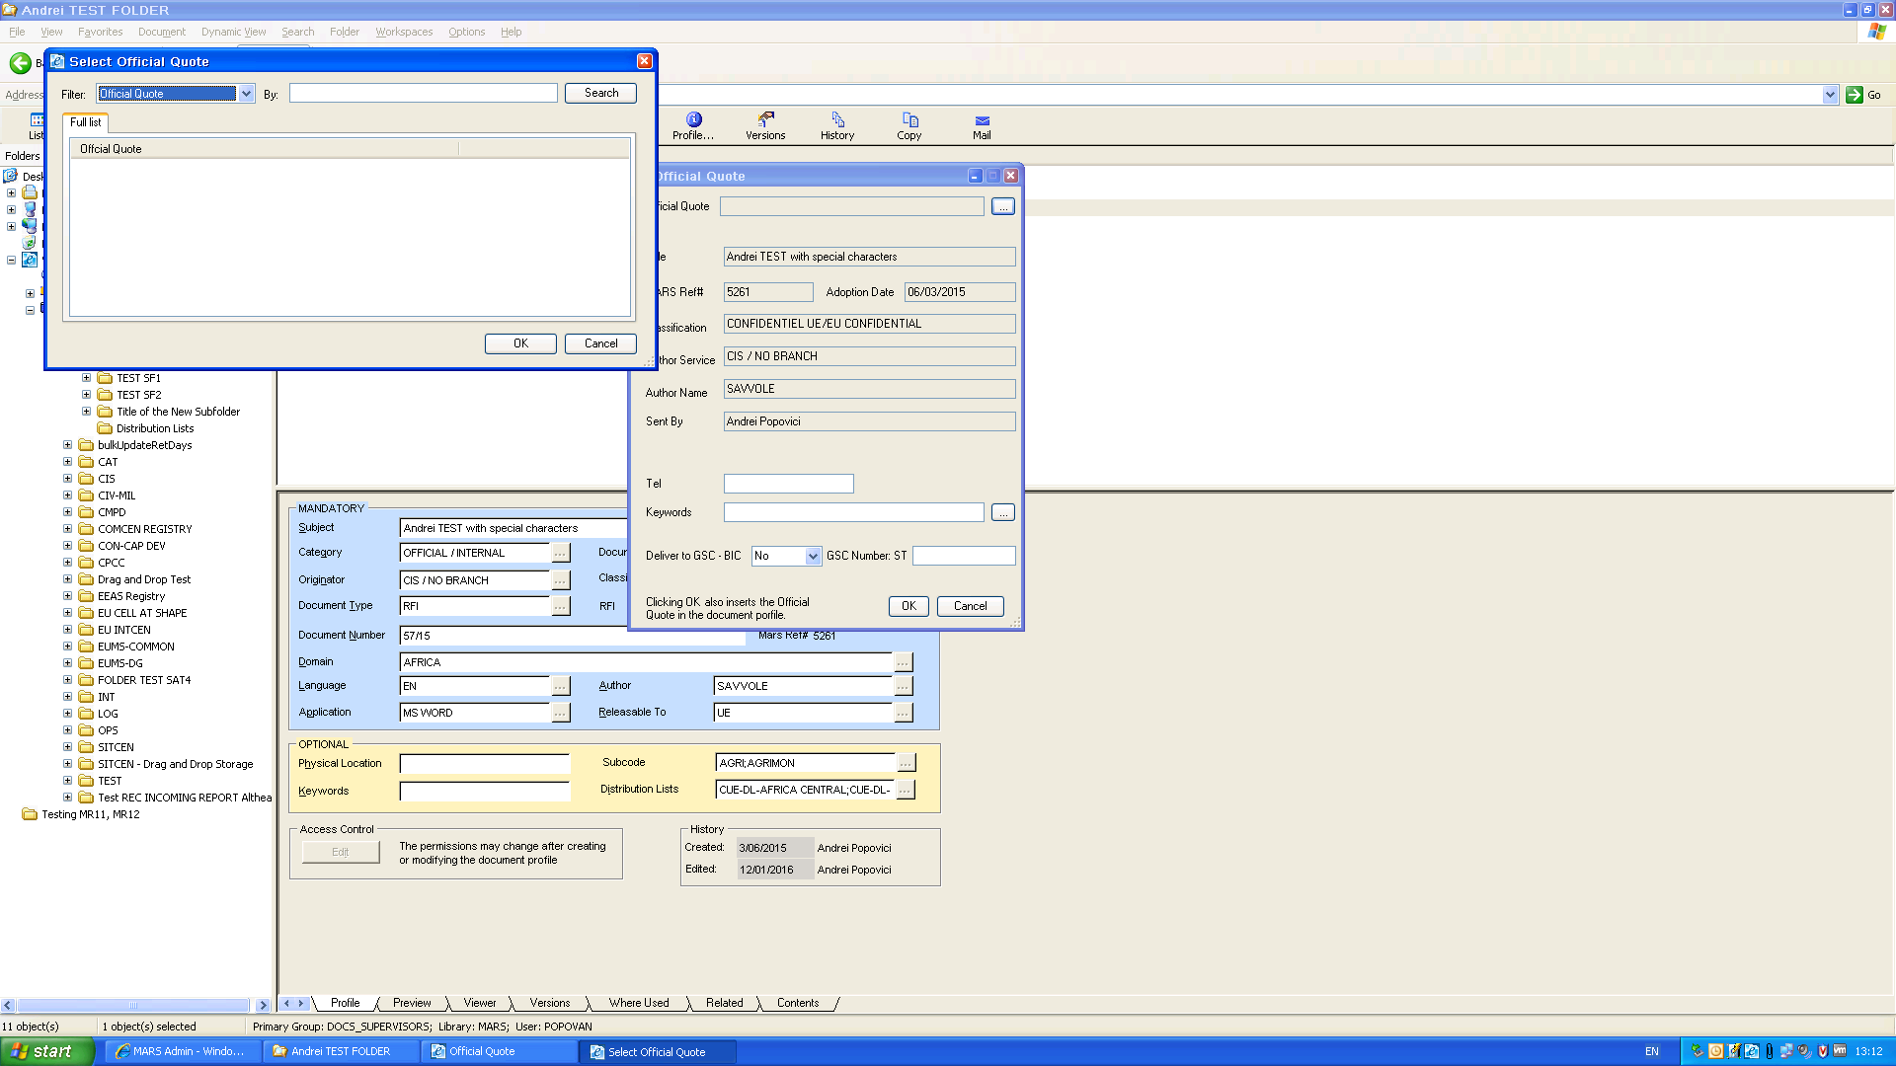
The list is empty. EEAS 00001 is not available, even though the application showed as available EEAS 00002 which means EEAS 00001 has been booked already. Which actually is not true, could be a fake saving, and the proof is that I managed somehow to reproduce BUG1 by reseting EEAS 00002 back to EEAS 00001. ( which it doesn't seem to be possible anymore).
As a consequence, I cannot select the (supposed) available EEAS 00001 value from the list –it is empty - and cannot finalize the official quote.
REM: If we choose "New Suffix" option in "Select Official Quote Mode" form, then we get a list populated with EEAS 00001 value. We click "Cancel" (see also BUG 1 for [TC-MR12-38] Official Quote Automation – Request Official Quote – Suffix).
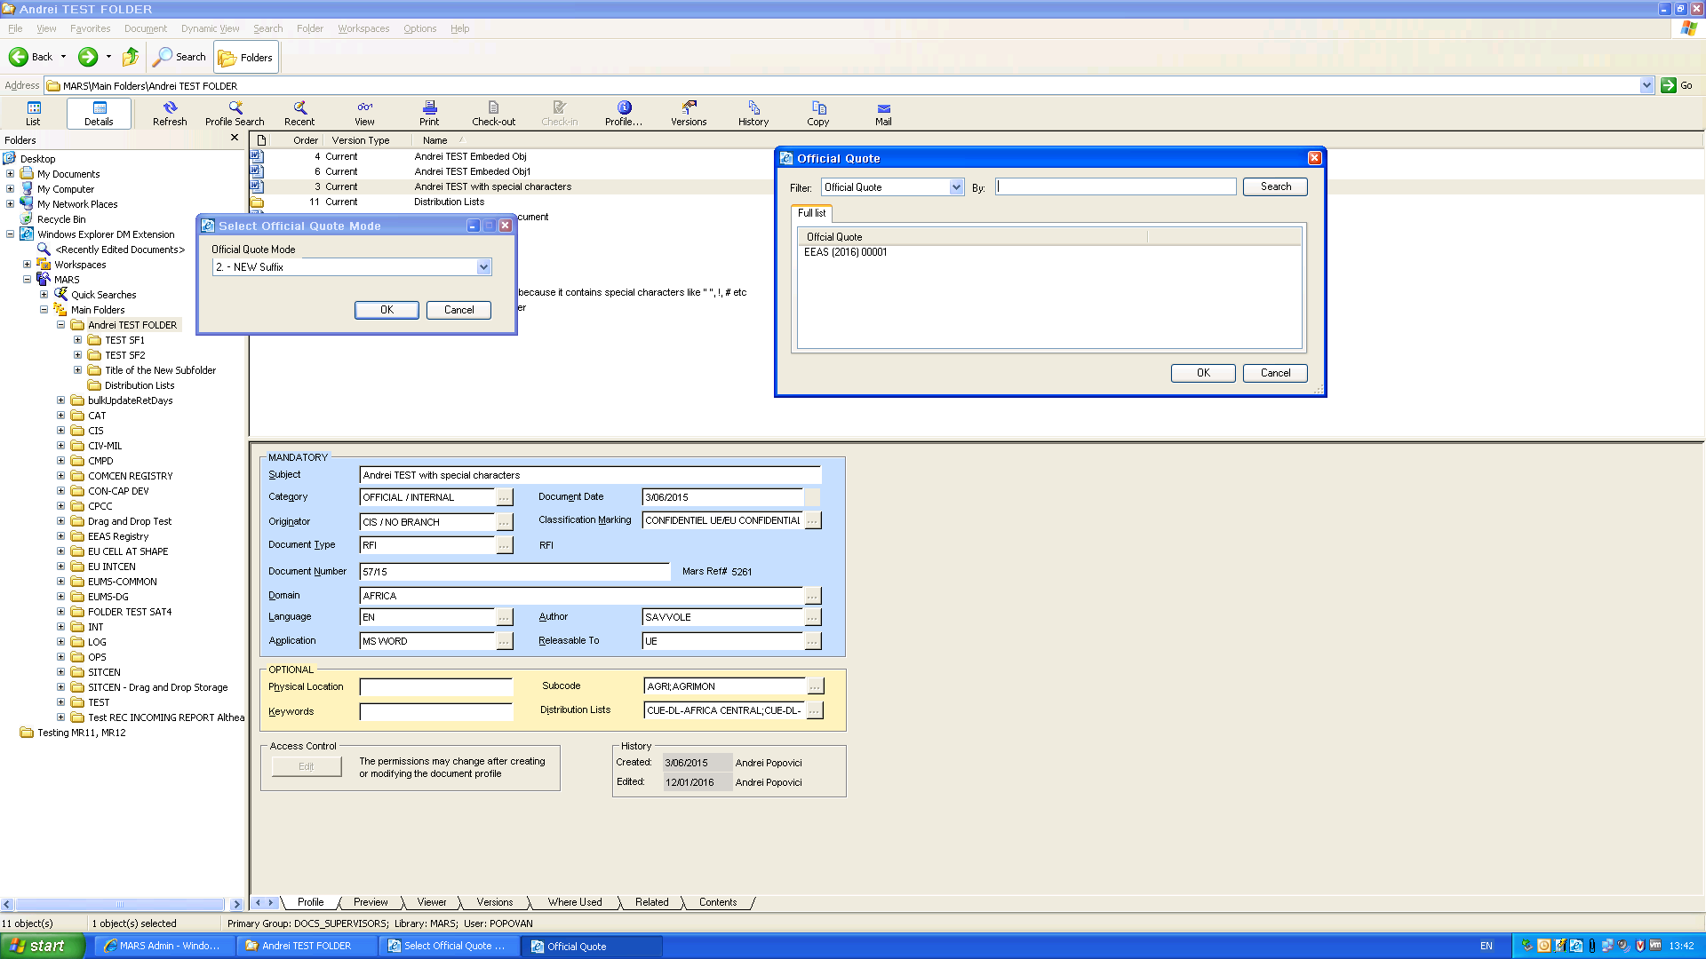

Same tests regarding ADMIN prefix:
BUG1:
BUG1
1. New range defined for ADMIN 2016 (1-99)
2. Select "New Official Quote" from the form "Select Official Quote Mode"
3. Click "OK" to display "Request Official Quote". The form displays ADMIN 00001 value (default)
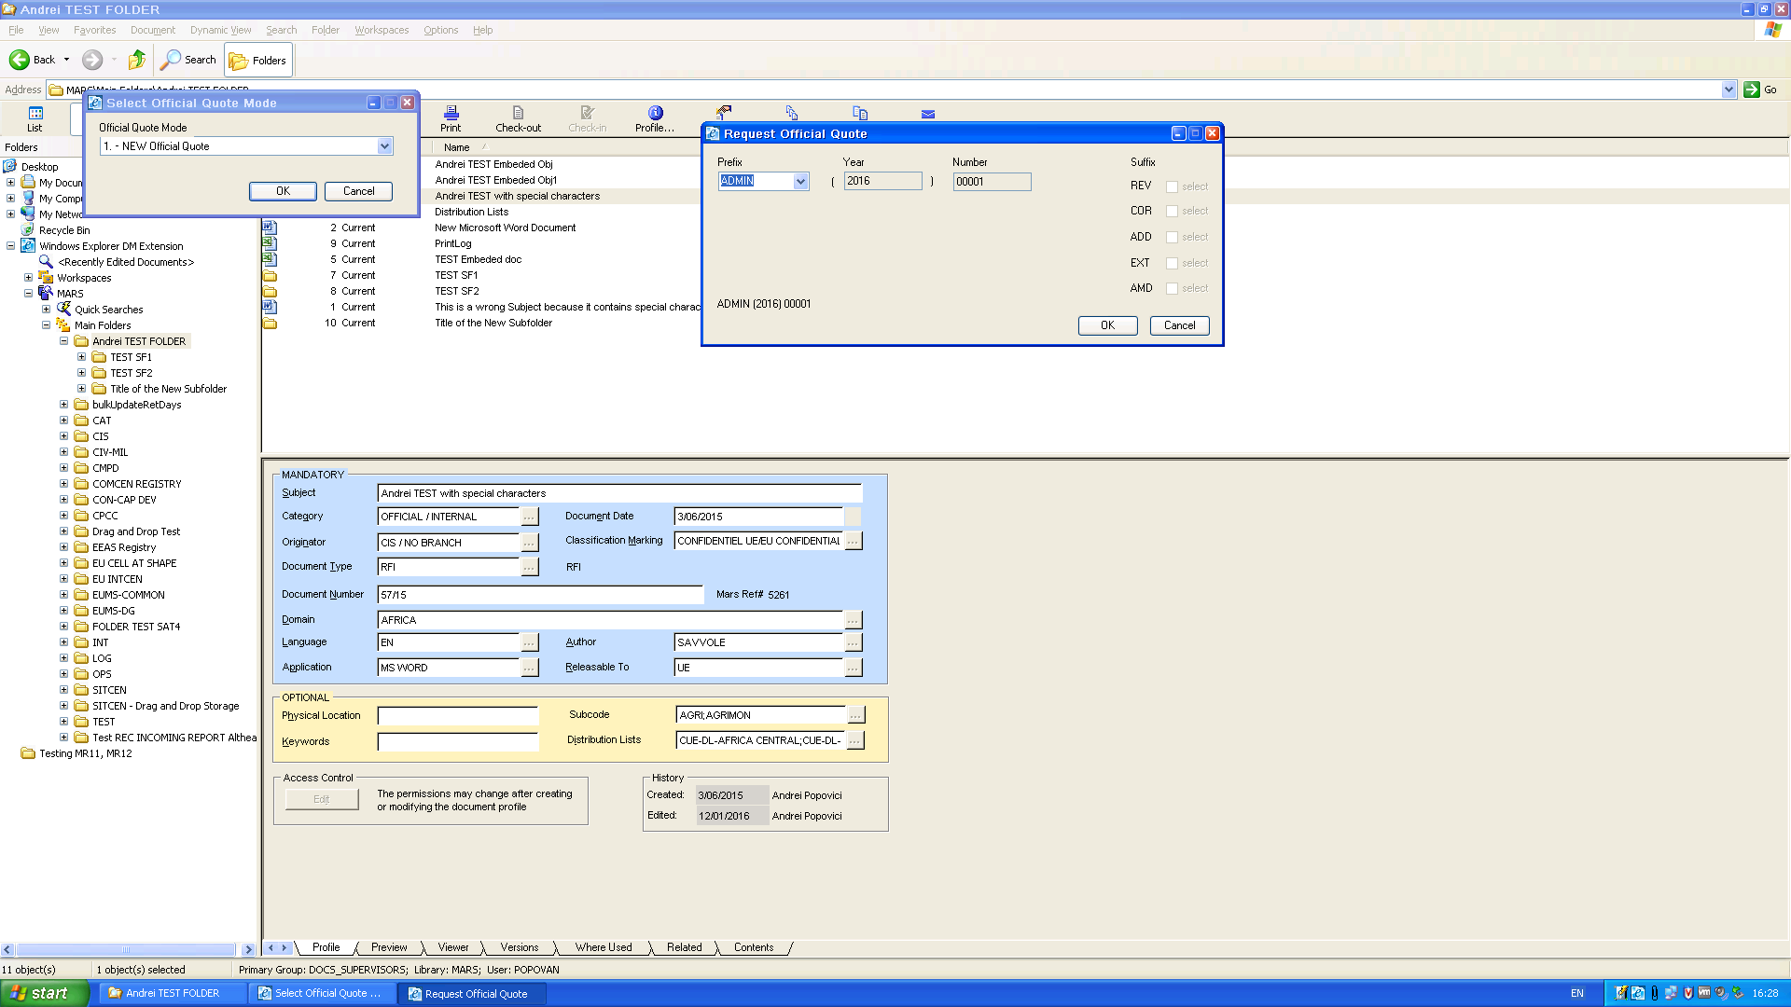

4. Click "Cancel";
5. Click "Cancel "in "Select Official Quote Mode". The ADMIN index remains 00001.
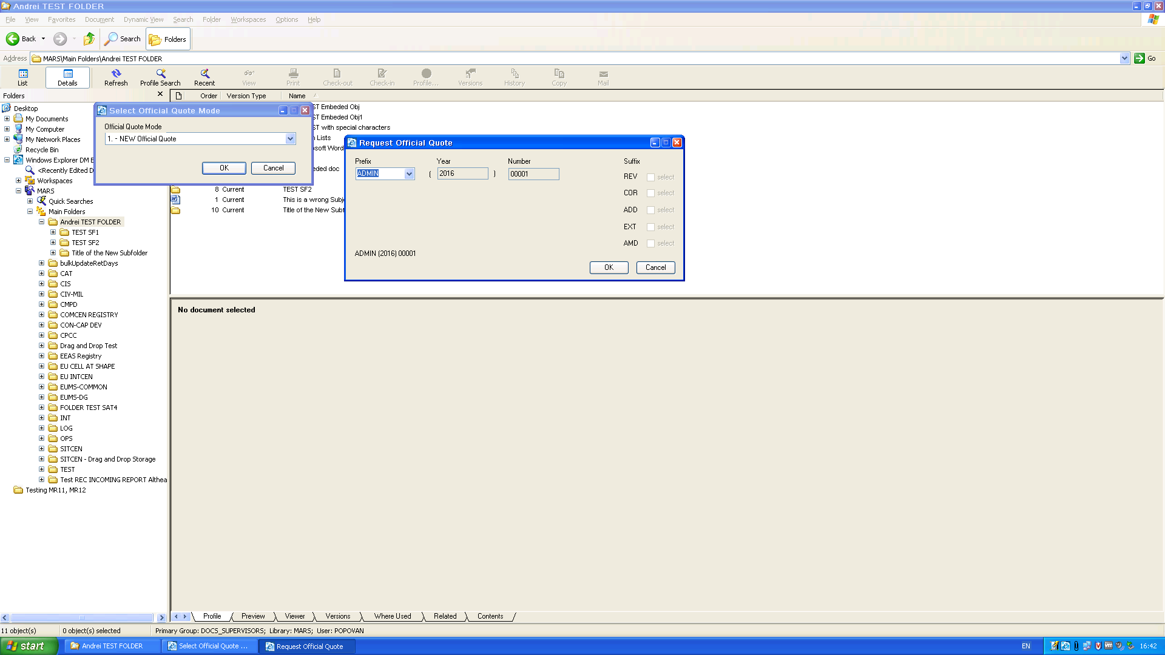

Tests regarding HR-COM prefix:
1. New range defined for HR-COM 2016 (1-99)
2. Select "New Official Quote" from the form "Select Official Quote Mode"
3. Click "OK" to display "Request Official Quote". The form displays HR-COM 00001 value (default)
4. Click "Cancel";
5. Click "Cancel "in "Select Official Quote Mode". The HR-COM index remains 00001.
6. Select "OK" to book HR-COM 00001 | 2 | 3. It books OK the 3 values. Next value available:
HR-COM 00004.
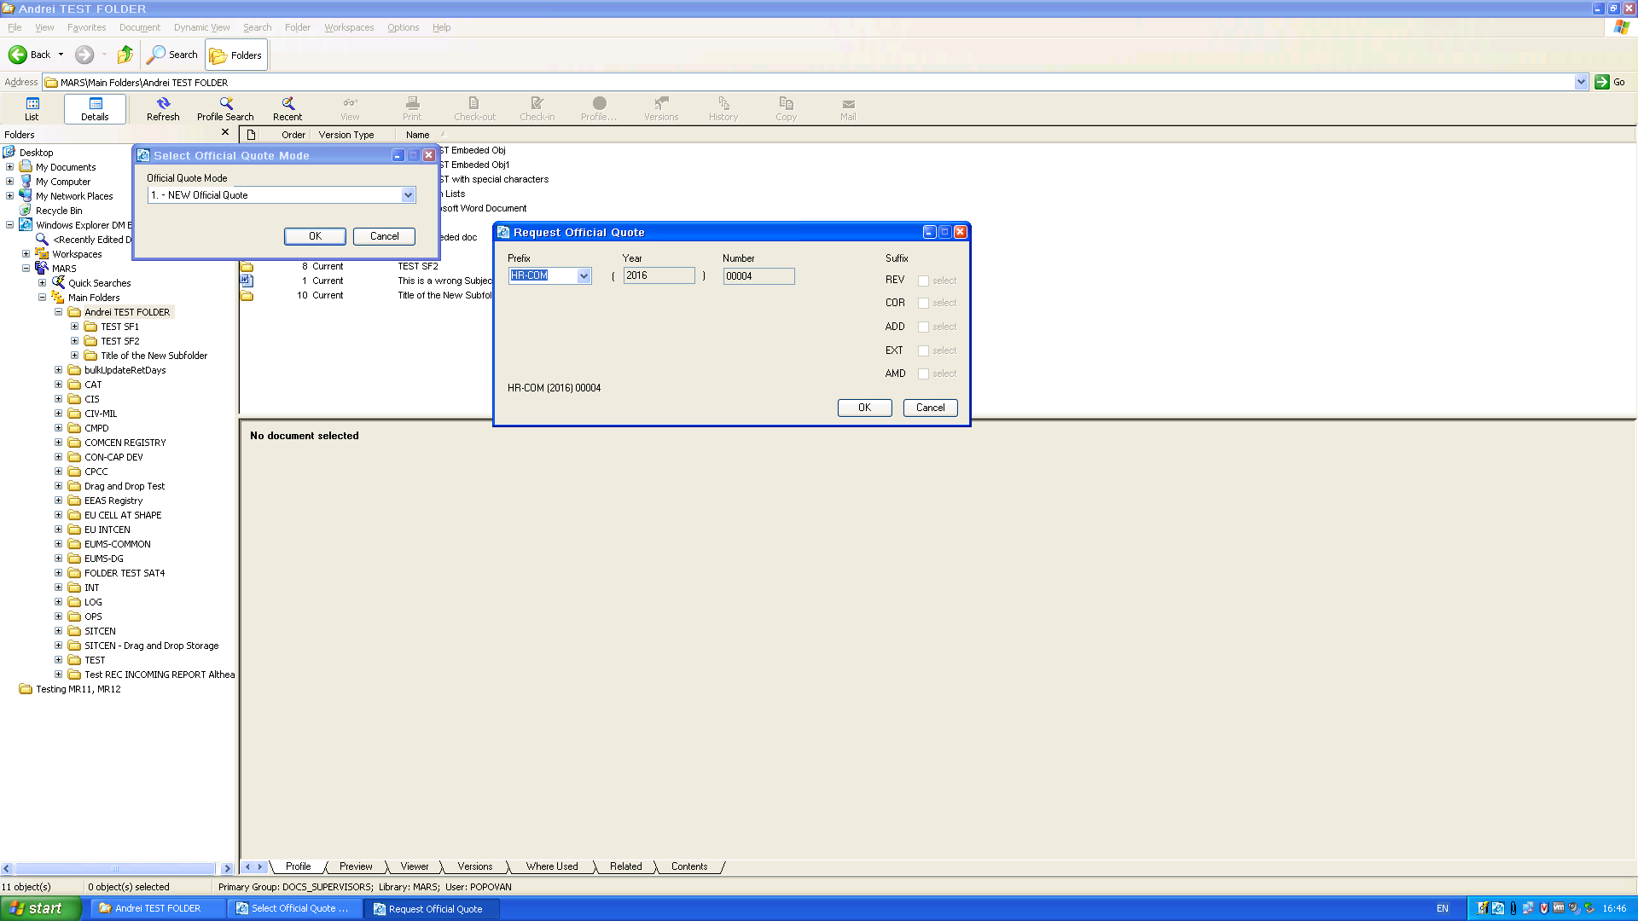
7. Click "Cancel". The last booked Official Quote is HR-COM 00003. We should see them available in the closed list when we select "Finalize…"
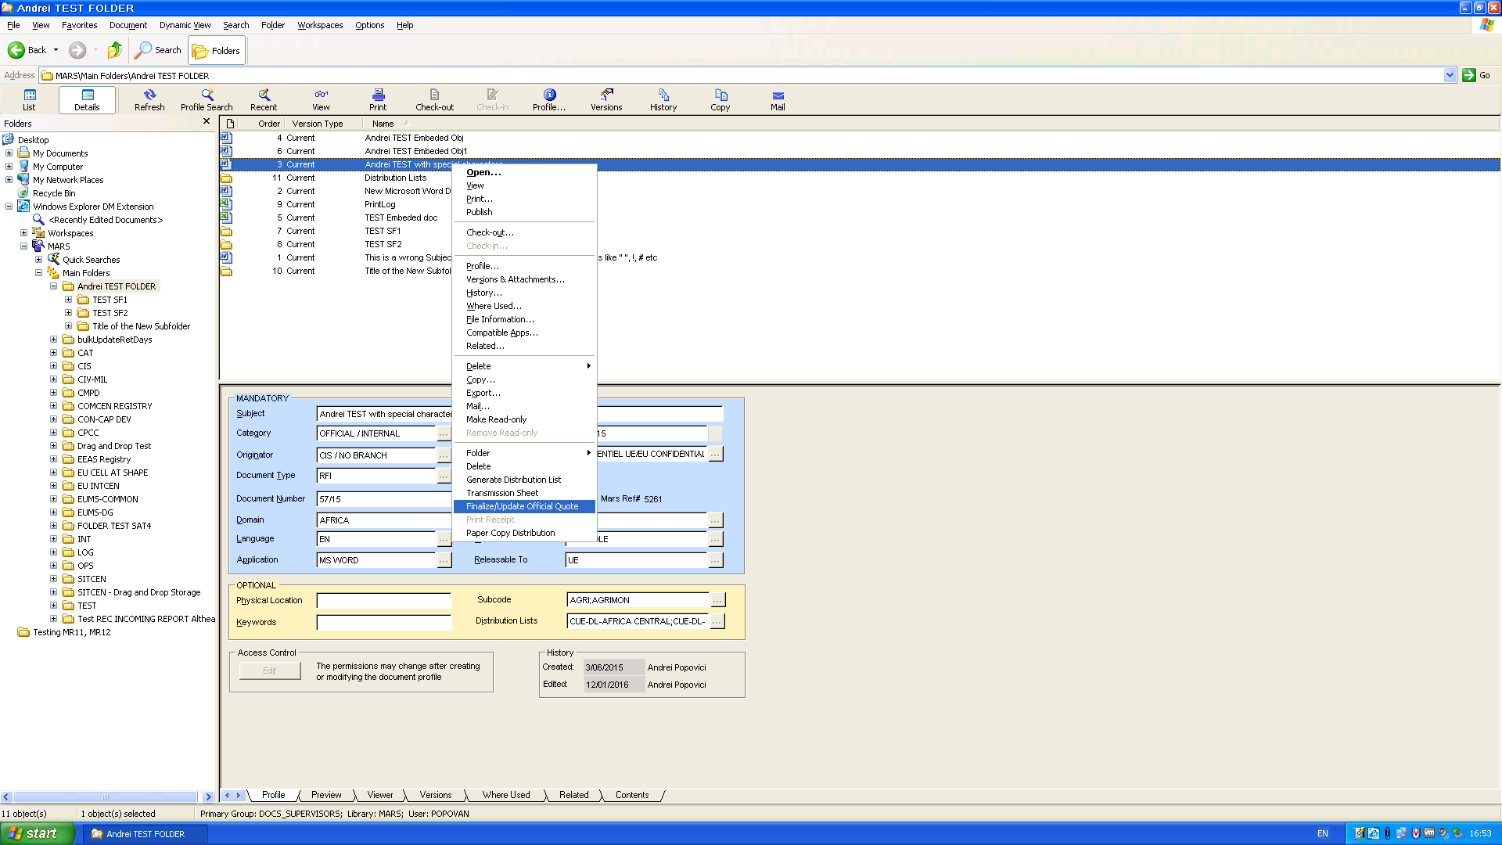
The 3 indexes from HR-COM are available in the list:
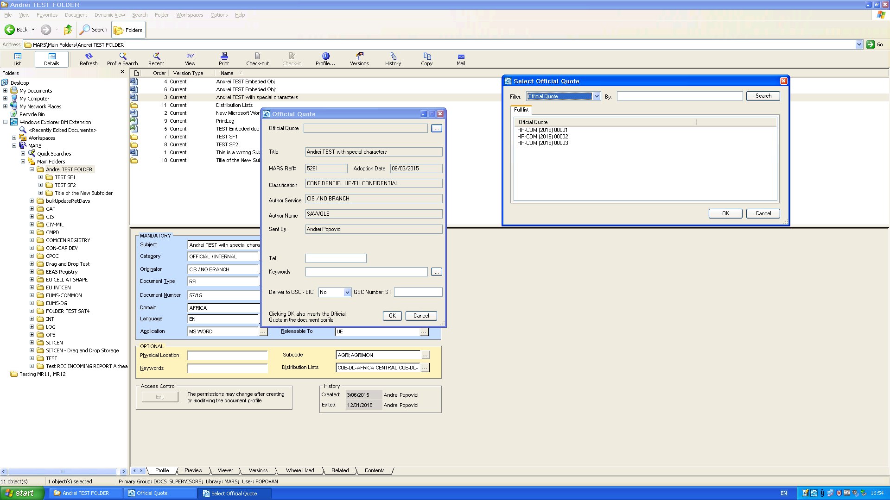

Click "Cancel" here.We do book EEAS 00002, EEAS 00003 and the same for ADMIN prefix, and expect to see them all in the list:
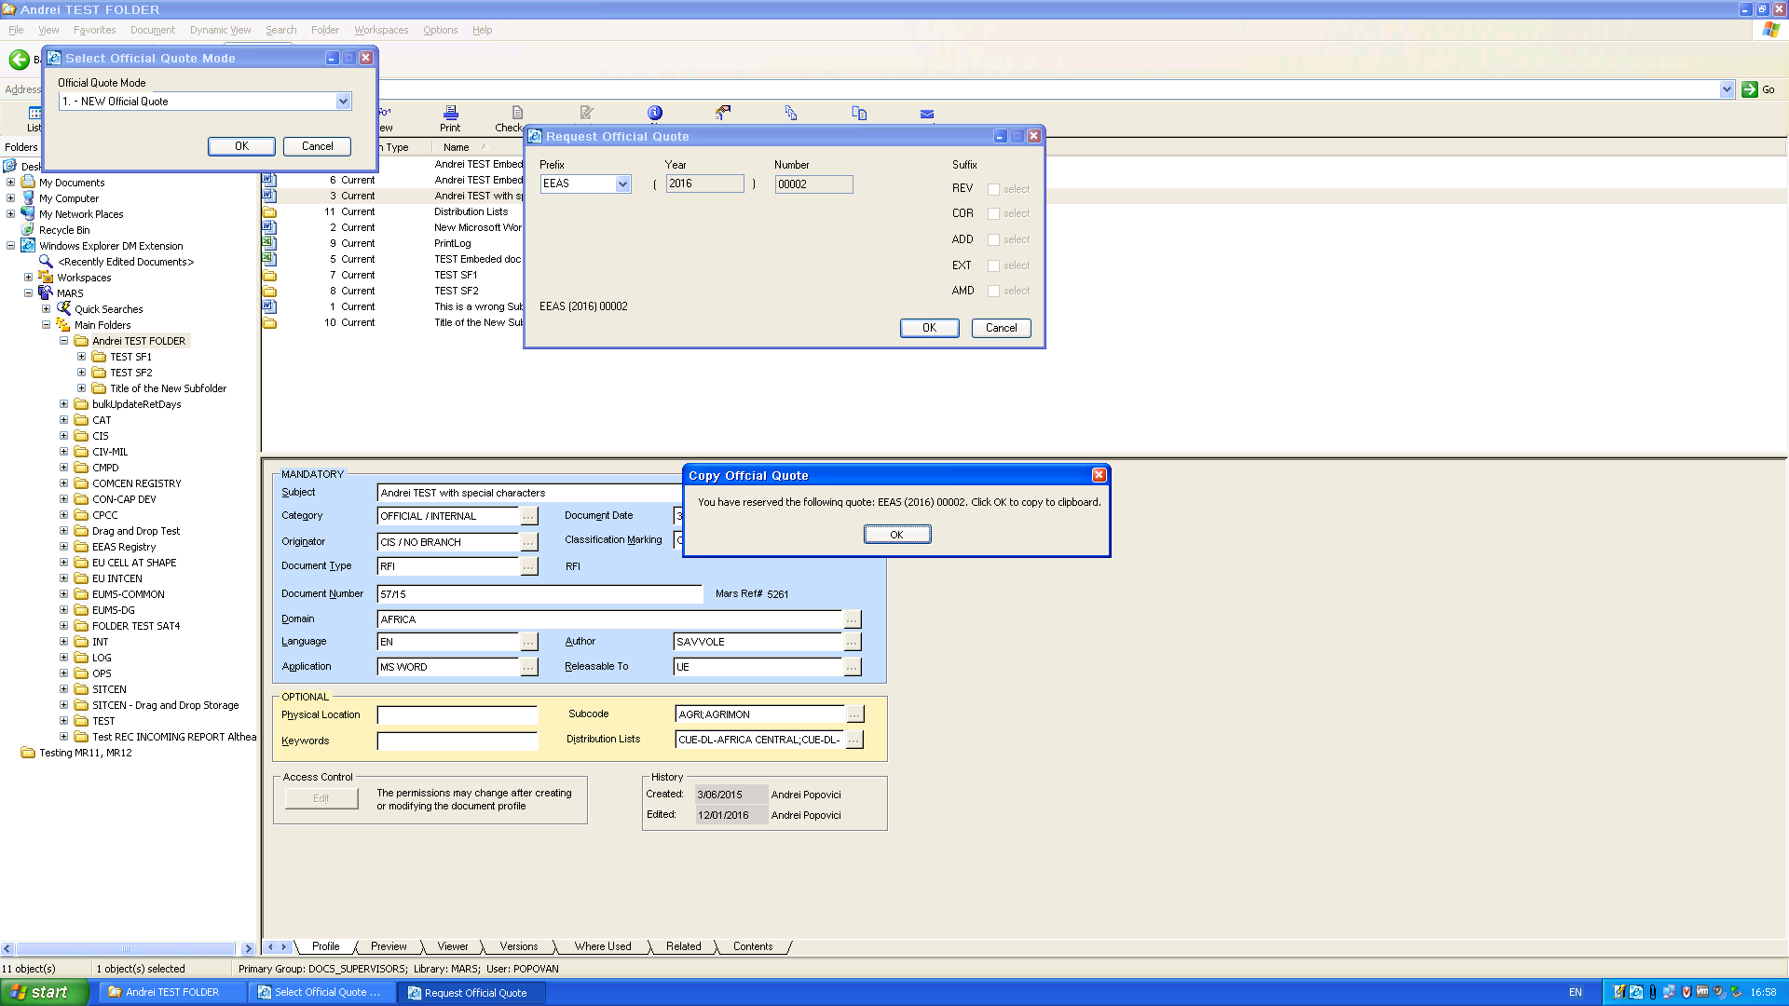
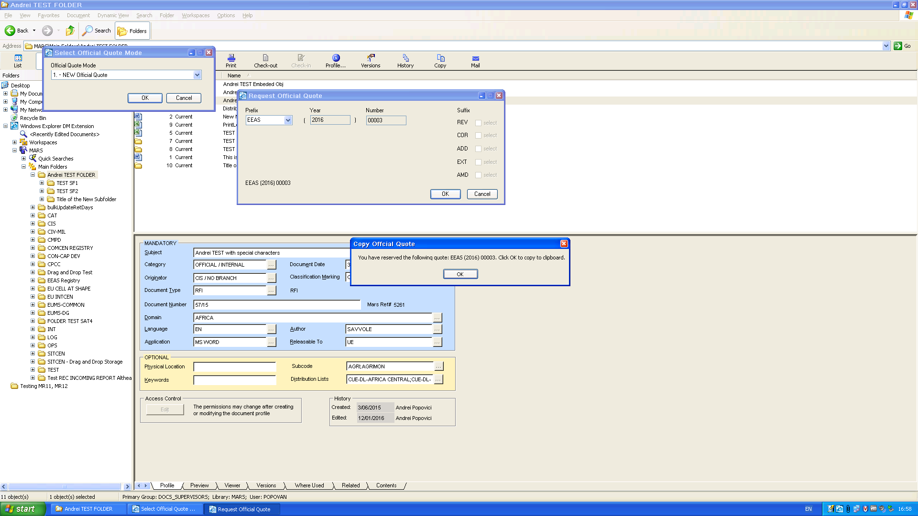
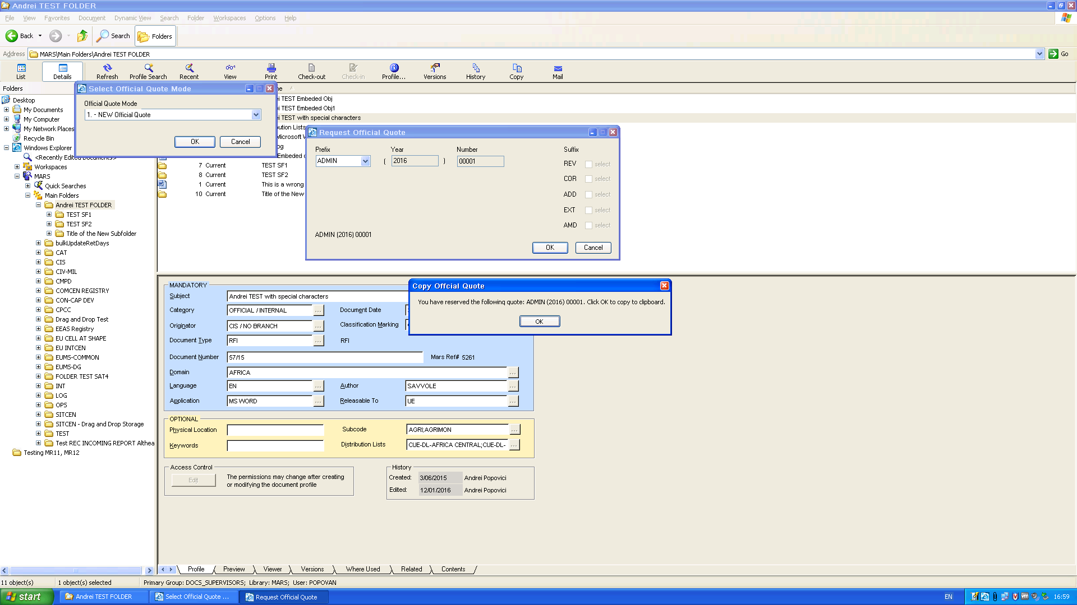
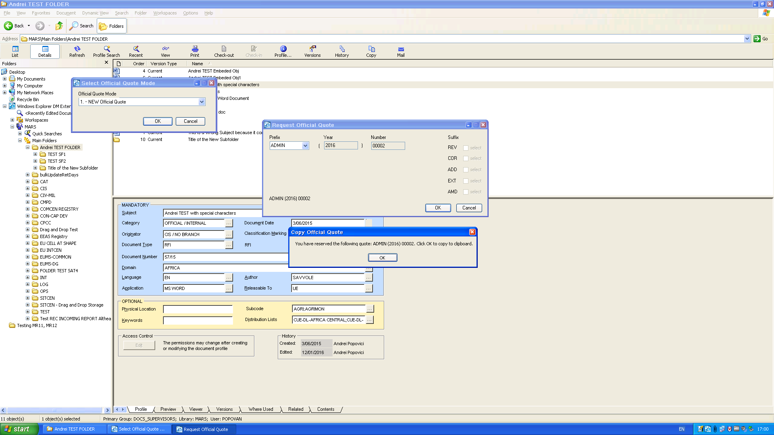
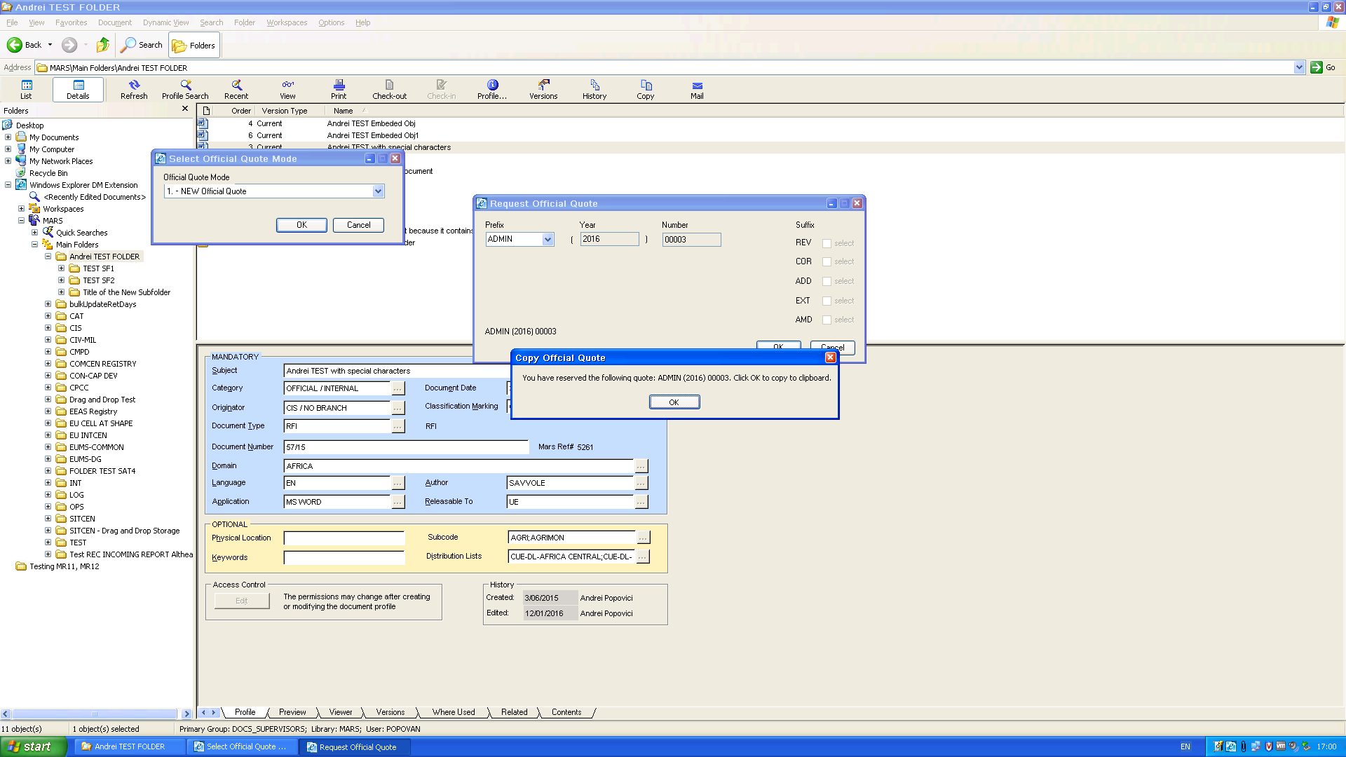
The final list:
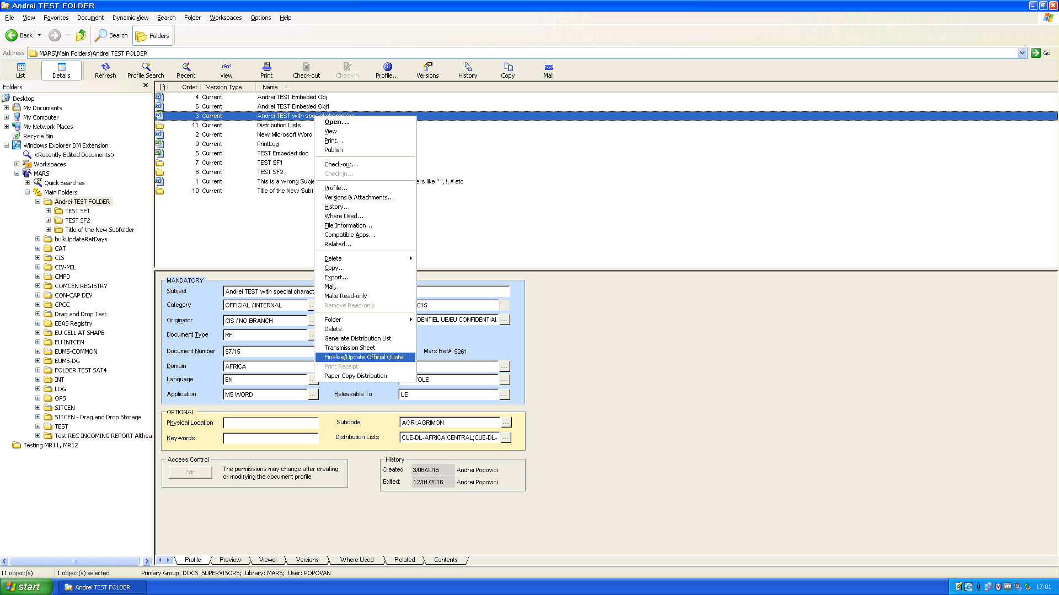
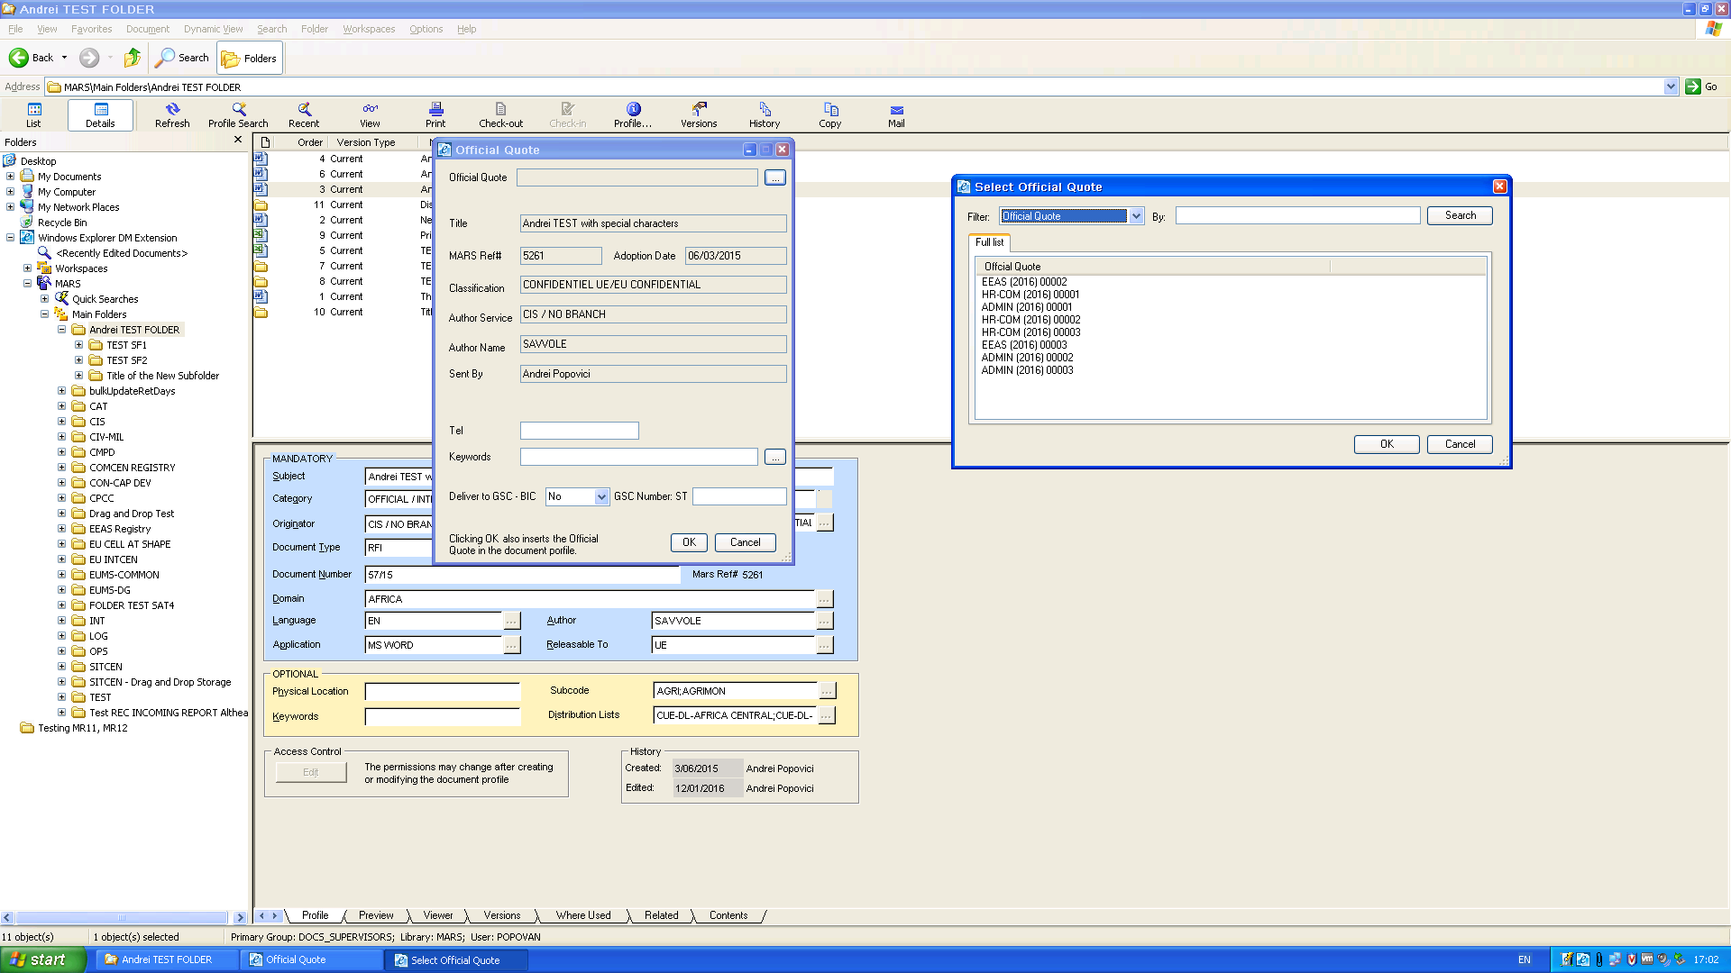

The Official Quote Log:
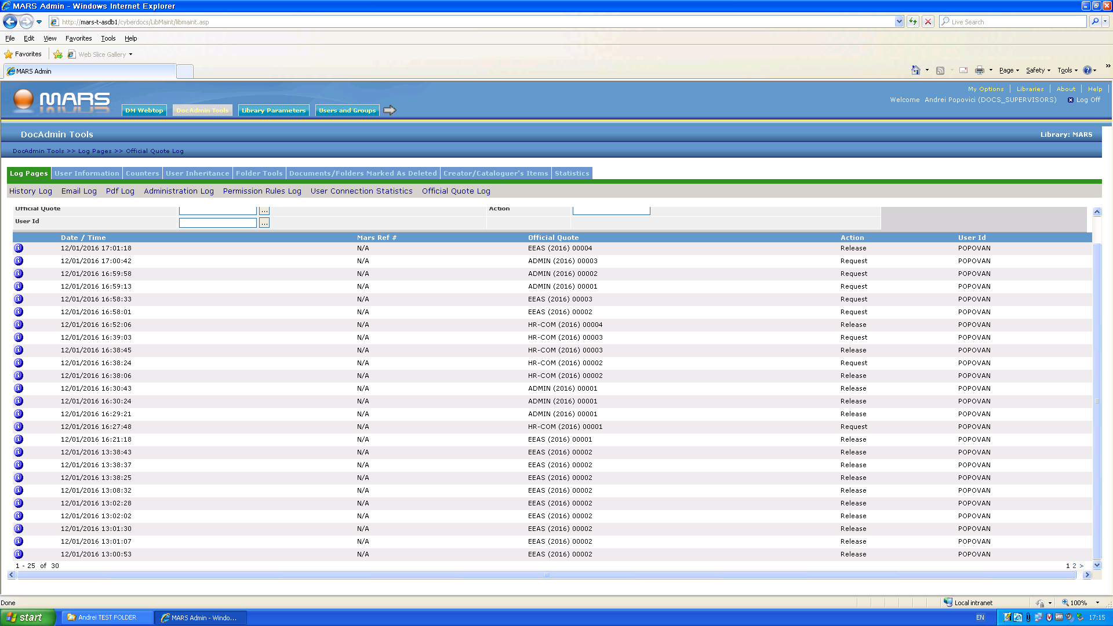
We see that EEAS00001 has been booked at 16:21:18 ( and we saw it the first time we logged in after logging off), however, EEAS 00001 is not available in the Official Quotes closed list.

Conclusion:
All Official Quotes have been saved properly, except for EEAS 00001 which is not available in the list.

